# **Formatted Output-printf()**

# **Refer sample_1.c**

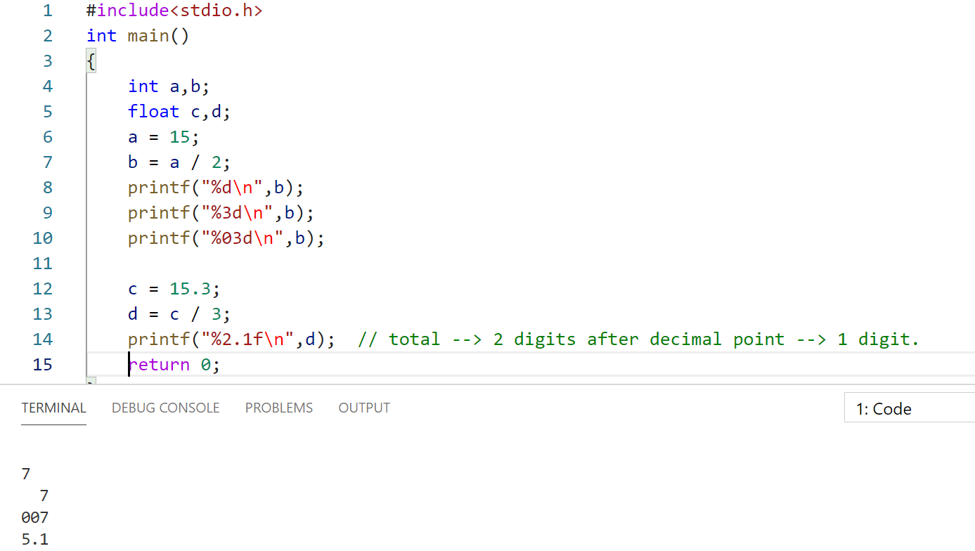

# **Refer sample_2.c**

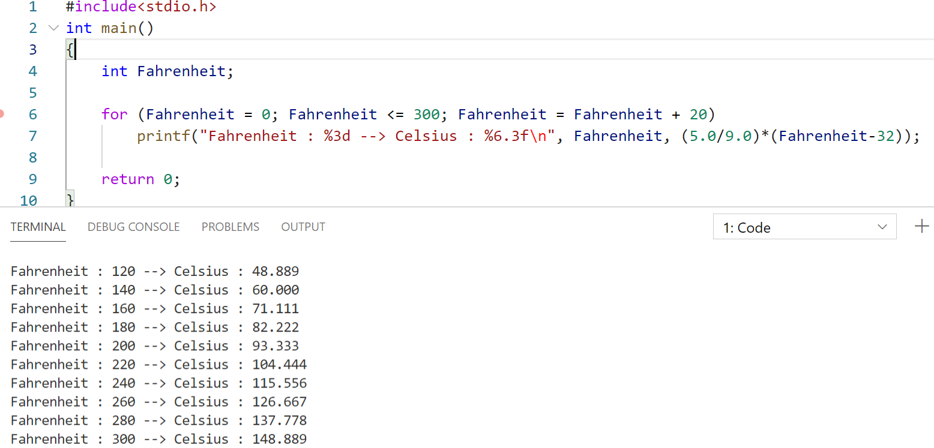

%3d 🡪 3 decimal digits.  
%6.3f 🡪 Totally 6 digits, After decimal point only 3 digits.

# **Refer sample_3.c**

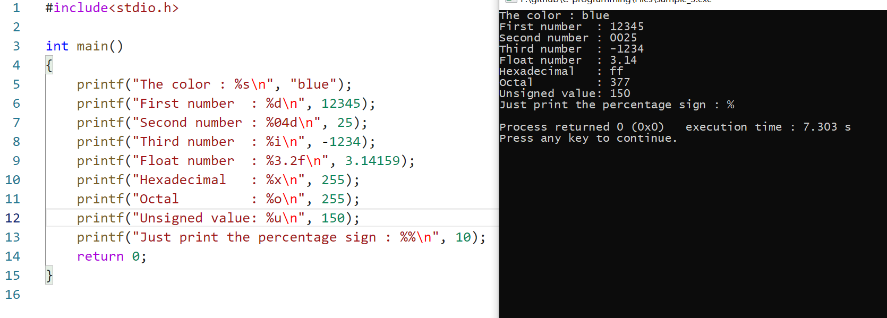

# **Refer sample_4.c**

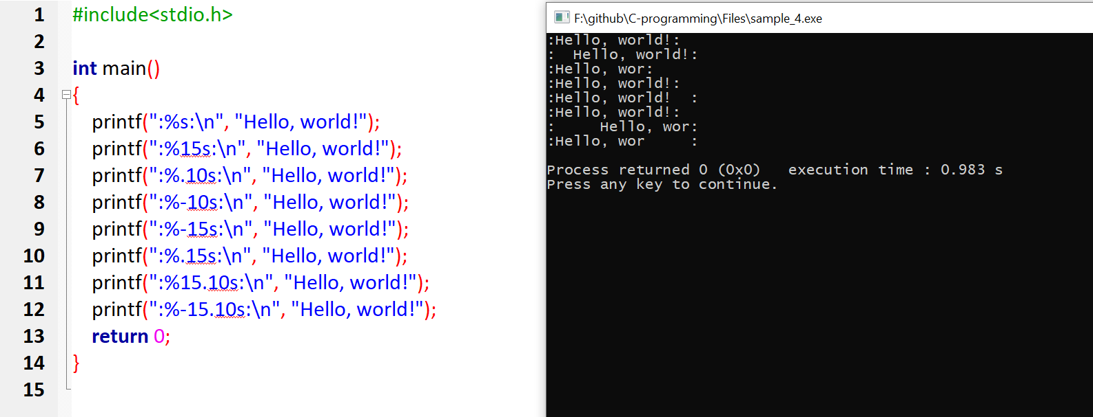

# **Formatted Input-scanf()**

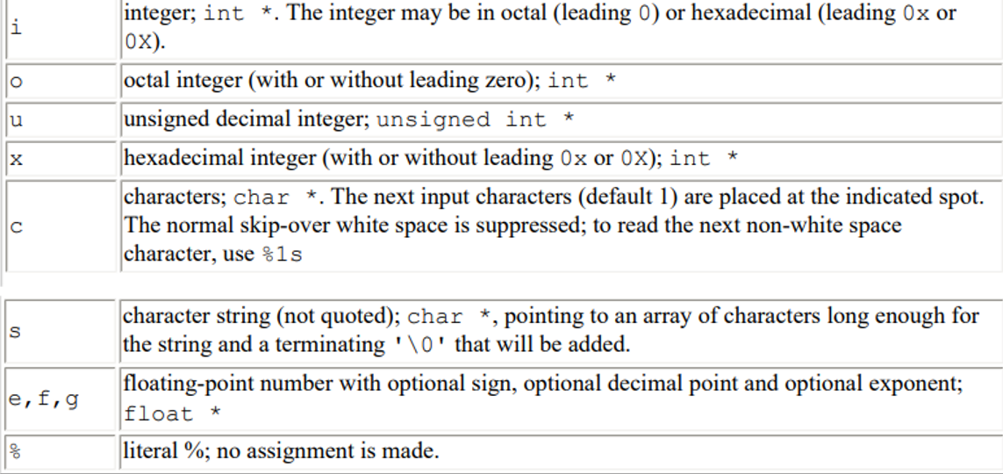

Return type of printf() and scanf() 🡪 int.  
scanf() 🡪 will return how many inputs it takes.

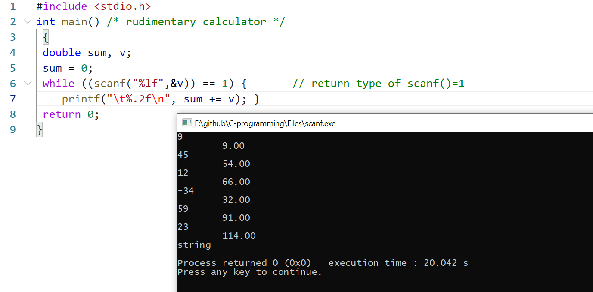

When scanf() fails its return type will not be equal to 1, so loop fails  
until we give numerical value, its return value=1.   
As soon as we give string, its return value!=1.

# **File-Operations**

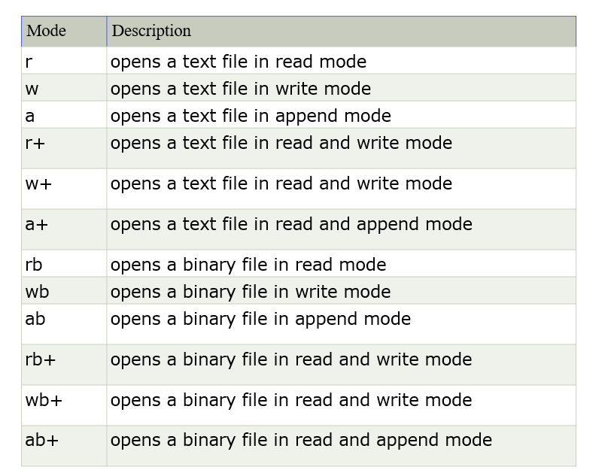

## **Reading the program itself**

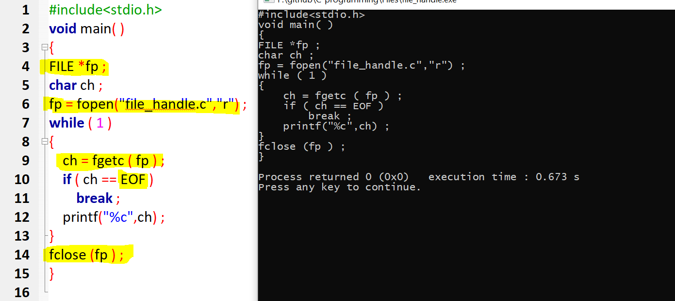

## **Writing and reading from a file(string)**

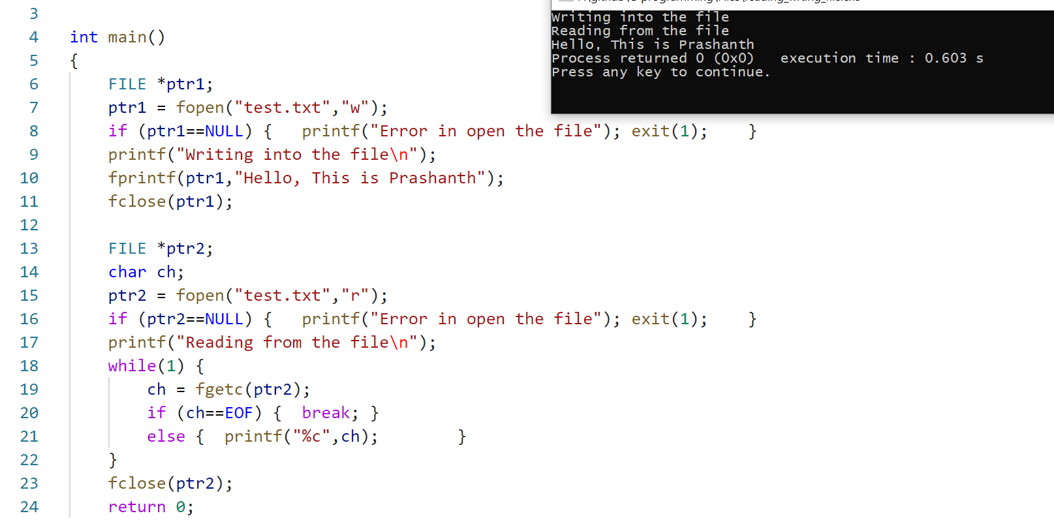

## **Writing and reading from a file [character] fputc() and fgetc()**

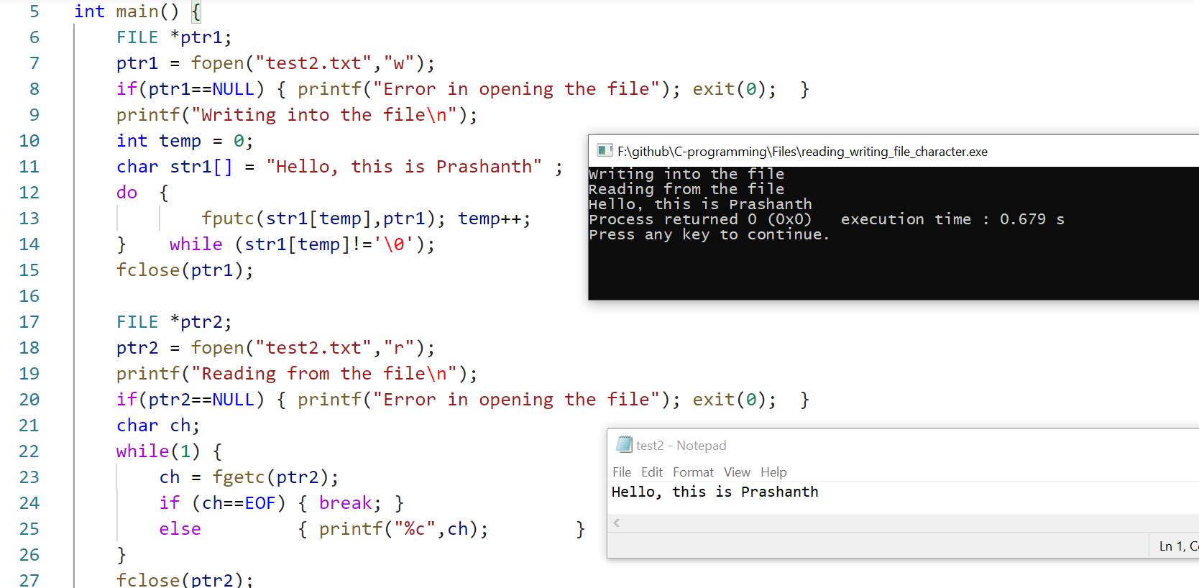

## **Writing and reading from a file [string] fputs() and fgets()**

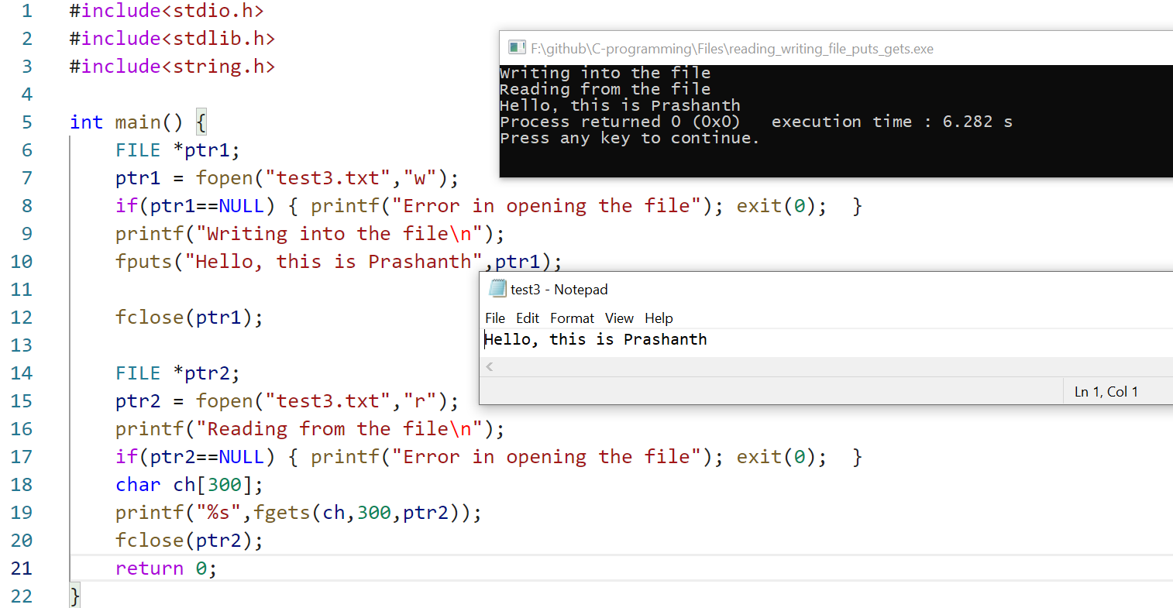

Refer perror_stderr_errno.c

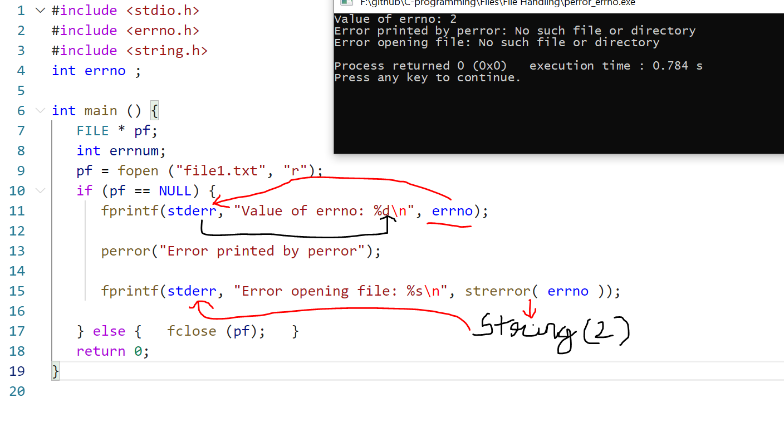

# ferror

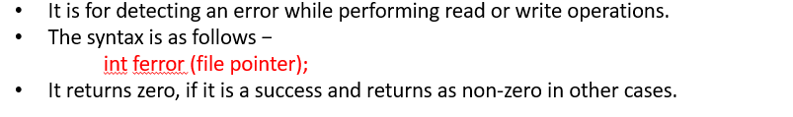

Refer ferror.c  
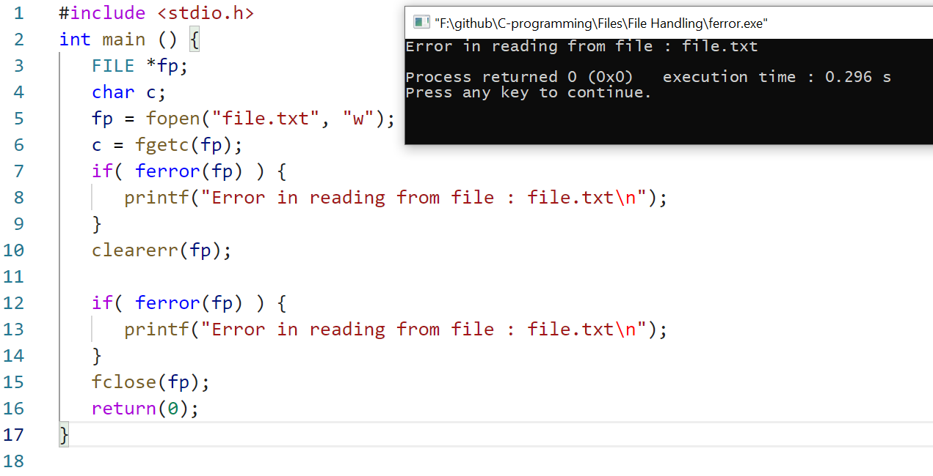

# feof

